Modern Method Software Engineering
Home work 2
Sike Huang | 850414-A394 | sike.huang@gmail.com | 0762320173
Shanbo Li | 840810-A478 | shanboli@Gmail.com | 0704646157

2007-9-23

Question 1: What is difference between <<extend>>, <<include>> and use case generalization relationships in use case diagrams. Emphasize your answer by giving an example. (Bonus Point 01)

Answer:
The difference between include and extend relationships is the location of the dependency. Suppose we are going to add a few use cases for the actor Dispatcher, say, OpenIncident, AllocateResources, and ConnectionDown.
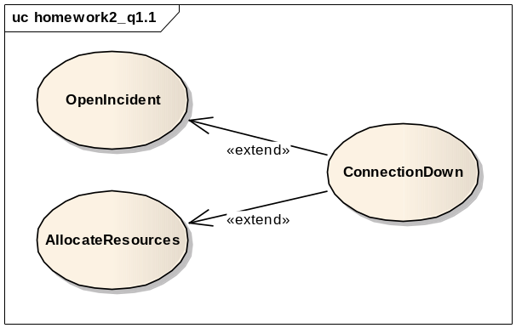
Figure 1-1 Simple diagram of extend relationship

If we model the ConnectionDown use case with include relationships, the authors of OpenIncident and AllocateResources use case has to know about and include the ConnectionDown use case. Conversely, if we use extend relationships instead, only the ConnectonDown use case needs to be changed to extend the additional use cases. In short, exceptional cases are modeled with extend relationships, whereas common behavior shared by use cases are expressed by include relationships.

The extend relationships and generalization relationships are also different. In a extend relationship, each use case shows a different flow of events to achieve a different task. In Figure 1.1, the OpenIncident use cases depicts the actions which take place when the Dispatcher creates a new Incident, in contrary the ConnectionDown use case describes the actions that occur during network crisis.
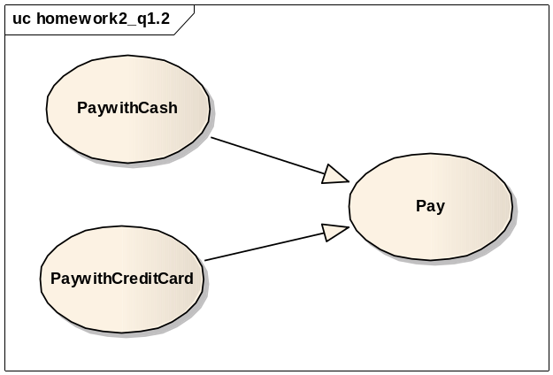
Figure 1-2 Simple diagram of generation relationship

In Figure 1.2, PaywithCash and PaywithCreditCard both explain actions that occur during Payment, however at different abstraction levels.

Question 2: Identify functional and nonfunctional requirements from the following description

Answer:
We have refined follow requirements from the description.

Functional Requirements:
- The allocation of staff to production lines should be mostly automated.
  - It describe a requirement of allocation of staff, if it cannot mostly automated allocate the staff to the production line, the staff in production planning(system operator) will have to do it himself. It is an interaction between user and system. So it is a functional requirement.
- Process based on the skills and experience of operatives.
  - It is what customer asked the allocation system developer to realize. And it is the rule to carry out the allocation.
- Details of holidays and sick leave will also be taken into account.
  - It is what customer asked the allocation system developer to realize. And it is also the rule to carry out the allocation.
- Only staff in production planning will be able to amend the automatic allocation to find-tune the list.
  - It reflects only certificate user could operate the allocation system. It is something about interaction between user and system.
Table 2-1 Functional Requirements

Nonfunctional Requirements:
- A process will be run once a week to carry out the allocation.
  - Performance
- A first draft allocation list will be printed off by 12.00 noon on Friday for the following week.
  - Performance, time associate.
- Final Allocation list is printed out by 5.00 pm.
  - Performance, time associate.
- The system must be able to handle allocation of 100 operatives at present.
  - Performance
- The system should be capable of expansion to handle double that number.
  - Performance
Table 2-2 Nonfunctional Requirements

Question 3: Consider the following Scenarios and refine the use case diagram given on page 03. You should create a new use case diagram, you should point out the places where other use cases get included, extended or generalized, and mark possible extension points.

Answer
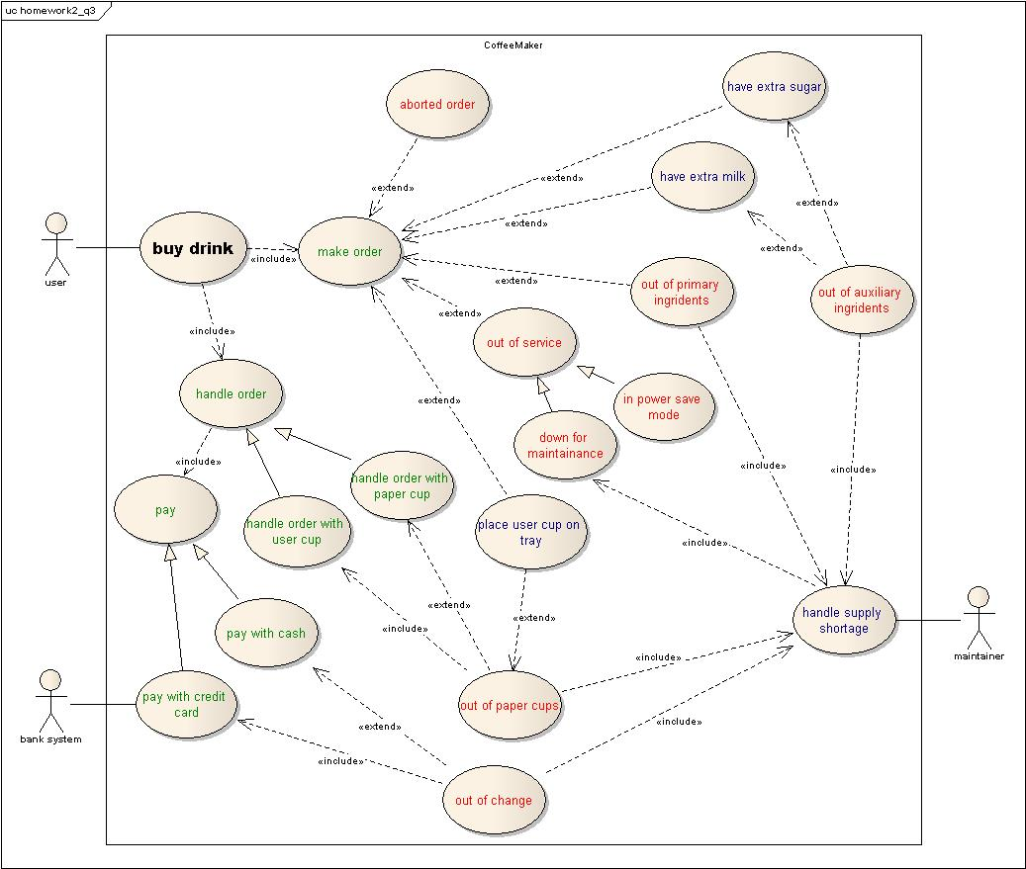
Figure 3-1 Refined use case diagram of CoffeeMaker
We arrange the use cases into four categories:
Categories | Describe | Member
Main use case | High-level use case. | Buy drink
Primary use case | Describe the core events that coffeemaker system is interested in. | make order, handle order(handle order with user cup, handle order with paper cup), pay(pay with credit card, pay with cash).
Secondary use case | These use cases stands for the events that coffeemaker system takes care, but they are not mainly focused on. | have extra milk, have extra sugar, place user cup on tray, handle supply shortage
Exceptional use case | These use cases happens only under exceptional conditions. | aborted order, out of primary ingredients, out of auxiliary ingredients, out of paper cup, out of service(down for maintains, in power save mode), out of change
Table 3-1 Use case categories table

Question 4: Consider an Academic Payroll System for a University:

1. Identify few actors (at least 2) and their scenarios (at least 1 for each actor) and identify use cases for the problem (at least 02 use cases). These use cases should be presented as textual description (see p. 163)
Answer:

Actors:
- Employees in the Personnel Department
  - Manager of AP system
- Full-time academics
  - View payment details, leave balances, and personal information; update personal details and payment method.
- Casual academics
  - Submit timecard to AP system, receive notification from AP system(if required)
- The University
  - Deducts standard tax rates from payments made to full-time academics.
Table 4-1-1 Actors of AP system

Scenario:
Scenario name | AddNewCasualAcademic
Participating actor instances | Tom: EmployeeInPersonnelDepartment  Jerry, Danna: CasualAcademic
Flow of events | - The University just contracts with two new Casual Academics. As an Employee In Personnel Department, Tom is asked to add Jerry and Danna to AP system.  - Tom login to AP system via a windows-based interface on his laptop.  - Tom adds Jerry to AP system as a Casual Academic with Jerry’s information. Then he gets AP system’s echo with “New Casual Academic Adding Successful”. And Tom also adds Danna with the same way.  - AP system sends e-mails to Jerry and Danna, and notifies them that they have been enrolled to AP system, and ask them to confirm their information.  - Jerry confirms the information.  - Danna finds that her age is not correct and sends an e-mail back to Employee In Personnel Department with right information.  - Tom receives Danna’s e-mail and edits the age of Danna in AP system.  - AP system sends Danna a email with new information, and ask for her confirmation.  - Danna confirms the information update.
Table 4-1-2 AddNewCasualAcademic scenario

Scenario name | UpdateAddressAndCheckPayment
Participating actor instances | John: FullTimeAcademic
Flow of events | - One Wednesday, John moves to a new house. He realizes that it is necessary to update his address in AP system. So he login to Academic Kiosk via safari, and wants to update his address.  - John inputs his new address and press update button.  - He finds that system echoes “personal information update successful”.  - John also checks if they pay him the recently fortnight salary.  - He finds that he got the money.
Table 4-1-3 UpdateAddressAndCheckPayment scenario

Use Case:
Name | UpdateFullTimeAcademicsInformation
Participating  Actors | Initiated by EmployeesInThePersonnelDepartment(EPD for short)  Update FullTimeAcademics(FA for short) information
Flow of events | 1. | EPD operators AP system and chooses to update FAs information.
Flow of events |  | 2. | System redirect to update FAs’ Information window.
Flow of events | 3. | EPD enters the key word to search a FA.
Flow of events |  | 4. | System search FA with the key word. If it matches some of the FA in database, system shows the FA which match the key word (maybe more than one). Ask EPD to choose one of FA to display information.
Flow of events |  | 5. | Otherwise, if no matched FA, system go back to start of search step and asks EPD to enter a new key word.
Flow of events | 6. | EPD chooses one of FA to show his/her information.
Flow of events |  | 7. | System shows the FA’s information.
Flow of events | 8. | EPD edits the FA’s information and upload to system.
Flow of events |  | 9. | System saves the latest data and notifies FA that his/her information has already updated.
Flow of events |  | 10. | System shows information update successful and asks EPD if he want to search a new FA or exit UpdateFullTimeAcademicsInformation mode.
Flow of events | 11. | EPD chooses to search a new FA.
Flow of events | 12. | Otherwise EPD finds that all FA’s information is up-to-date and exit UpdateFullTimeAcademicsInformation mode.
 | 13. |  | System goes back to start of search step.
 | 14. |  | Otherwise system exits UpdateFullTimeAcademicsInformation mode.
Entry  Condition | - EPD login to AP system
Exit  Conditions | - ALL FAs’ information are up-to-date.
Quality  Requirements | - FA can receive the information update notification and communicate with EPD if the FA found any information that have just been updated are wrong.
Table 4-1-4 UpdateFullTimeAcademicsInformation use case

Name | ViewPaymentDetails
Participating  Actors | Initiated by FullTimeAcademics(FA for short)
Flow of events | 1. | FA click view payment details button on Academic Kiosk(AK for short)
Flow of events |  | 2. | AK redirect to view payment details window.
Flow of events |  | 3. | AK asks FA if he wants to see all history or just wants to check the latest details.
Flow of events | 4. | FA chooses to see all history payment details.
Flow of events |  | 5. | AK shows all payment details history. Including payment date, payment summary and payment method.
Flow of events | 6. | FA reads all his payment details and requests to see the latest payment details.
Flow of events |  | 7. | System shows the FA’s latest payment details. Including payment date and time, payment summary, and payment details.
Entry  Condition | - FA login to AK system via bowser.
Exit  Conditions | - FA has checkout his payment state details
Quality  Requirements | - FA can connect the EPD if he found his payment state is not the same as he wishes.  - Payment state has to be changed as soon as the University transfers money to FA’s bank account.
Table 4-1-5 ViewPaymentDetails use case

2. Extend of the identified use cases with exceptions handling

Answer:
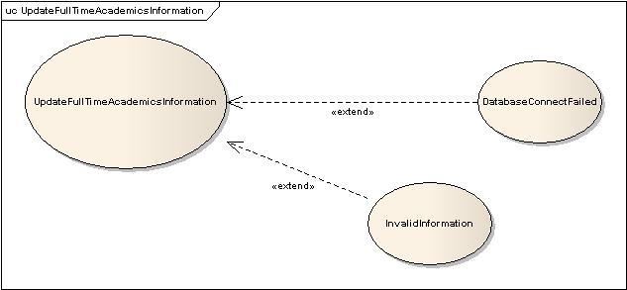
Figure 4-2-1 exception handling of UpdateFullTimeAcademicsInformation use case

InvalidInformation: | AP system warns that the information which EPD just inputs is invalid, and asks EPD to re-input information
DatabaseConnectFailed: | AP system warns that Database is not available at the moment, and asks EPD to try later.

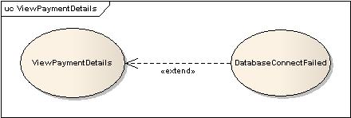
Figure 4-2-2 exception handling of ViewPaymentDetails use case

DatabaseConnectFailed: | AK warns that Database is not available at the moment, and asks AF to try later.

3. Describe of non-functional requirements
Answer:

Category | Nonfunctional Requirements
Usability | - In case a new AP has been added to AP system, She/he can access AK via a browser.
Reliability | - If exception occurs during EPD’s connect with AP system, it can restart.  - If exception occurs during FA’s connect with AK, it can restart.  - Automatically do backup of AP system fortnightly.
Performance | - AK must support many parallel connects from CAs. (e.g. 100)  - AP system must support many parallel connects from EPD(e.g. 10)
Supportability | - EPD must be able to add new items to FA or CA’s personal information on AP system.  - EPD must be able to change the standard of salary of FA or CA from AP system.
Implementation | - All FA should be able to access AK from a web browser supporting cookies, JavaScript.  - FA or CA cannot access from web browser.  - EPD should be able to access AP system via a windows-based desktop interface.  - AP system should run on any Unix operating system (e.g. MacOS X, Linux, Solaris).
Operation | - AK should be very easy to use so that FAs do not need any training in order to use it.
Legal | - All EPDs require secure authentication to use AP system.  - Any EPD cannot publish FA or CA’s payment details.  - An FA or CA’s payment details cannot be seen by any others except EPD.  - FA or CA can claim for a correct payment as required by local laws, if he cannot get agree with University on the salary they paid.
Table 4-3-1 nonfunctional requirements of AP system

Abbreviation about the nonfunctional requirements table above:
AP system | = | Academic Payroll system
EPD | = | Employees in the Personnel Department
FA | = | Full-Time Academics
CA | = | Casual academics
AK | = | Academic Kiosk

